**Analysis of Sales Report of a Clothes Manufacturing Outlet**

**Step-1**

* **Importing and Pre-processing data**
* **Renaming categorical value for levelling**
* **Converting the Required data to categorical value using factor**
* **Replacing missing values**
* **Split data into test and training set**
* **Applying feature scaling for standardisation**

**Step-2**

* **Multiple Linear Regression for how the style, season, and material affect the sales of a dress**

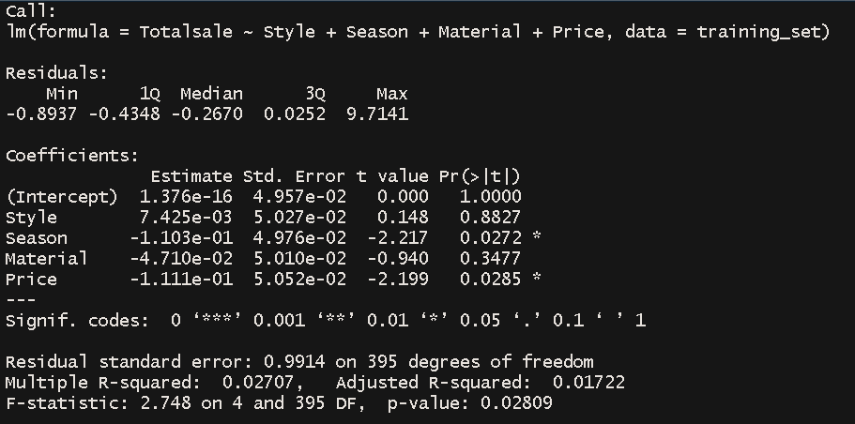

**Price is slight influential than style on sales**

* **Multiple Linear Regression for attributes affecting sales**

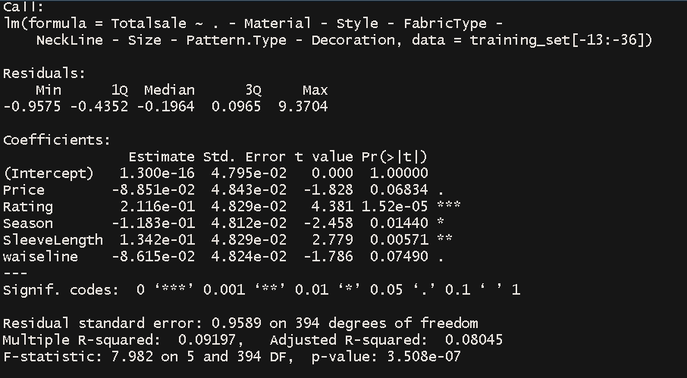

* **Linear Regression for finding effect of rating on total sales**

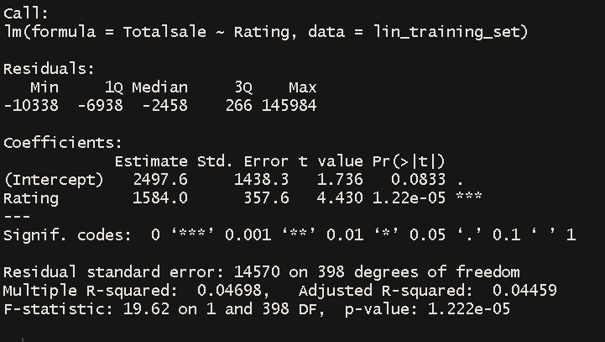

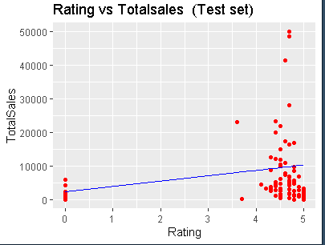

* **Random Forest for prediciting Recommendation**

